**Got It!**

**1. Evaluating performance**

You now know more about different model types and their outputs.

**2. Evaluate step**

But how do we evaluate a model's output? This is step 4 of the workflow.

**3. Overfitting**

The first thing to look for when evaluating is overfitting. That's when our model performs great on training data, but poorly on the testing data. This is bad: it means our model learned the training set by heart and is unable to generalize learnings to new data, which is what we originally want. This is why we need to split our dataset into two sets.

**4. Illustrating overfitting**

For instance, the green line here overfits. It's going out of its way to classify all points perfectly, thus performing great on this dataset, but poorly on unseen data. The black line makes more errors on this specific dataset, but generalizes better.

**5. Accuracy**

In our college acceptance problem, how would we measure the model's performance? We could use accuracy, which is the number of correctly predicted observations divided by the number of all observations. We had 48 correct classifications out of 50, which is a 96% accuracy.

**6. Limits of accuracy: fraud example**

However, accuracy isn't always the best metric. Consider fraud where only a small minority of transactions are fraudulent. Let's say we train a model to predict whether a transaction is fraudulent or legitimate. Here is a graph showing its performance on 30 test data points. It only misclassifies 2 points, giving it an accuracy of about 93%, which sounds good. But the model actually misses the majority of fraudulent transactions, which will be a problem if we deploy this model in the real world. We can even say all points are legitimate, and we get a 90% accuracy, but we miss all the fraudsters. In this case, we need a better metric.

**7. Confusion matrix**

Enter the confusion matrix. Let's fill it out.

**8. True positives**

True positives are fraudulent points that are correctly classified as fraudulent.

**9. True positives**

We only have one and that's the sole red point in the red area.

**10. False negatives**

False negatives are fraudulent observations that are incorrectly classified as legitimate.

**11. False negatives**

We have two false negatives. These are the red points outside the red area.

**12. Remembering False Negatives**

False Negatives are like telling a pregnant woman she's not pregnant.

**13. Fill out the rest...**

Getting a hang of it? Take a pause and try to fill out the remaining squares. How did it go?

**14. False positives, true negatives**

There are no false positives, meaning legitimate points that are incorrectly predicted as fraudulent. We see this because there are no blue points in the red area. True negatives are legitimate points correctly predicted as not fraudulent. These are the blue points in the blue area, totaling 27. If you add up all the squares, you should get the total of number of points, which is 30 here!

**15. Remembering False Positives**

False Positives are like telling a man he's pregnant.

1. 1 https://www.flickr.com/photos/59632563@N04/6104068209

**16. Sensitivity**

So why fill out this matrix? Remember, we wanted a better metric than accuracy for our fraud scenario. Sensitivity values accurate prediction of fraudulent transactions specifically by valuing true positives more. Here's the formula, which you don't need to memorize. We get 33% sensitivity, which is a bad score. Optimizing for sensitivity means we'd rather mark legitimate transactions as suspicious than authorize fraudulent transactions. Now, we see our model isn't good at predicting fraud and needs improvement.

**17. Specificity**

On the other hand we have specificity, which values true negatives. This is useful metric for spam filters. For an email user, it's better to send spam to the inbox rather than send real emails to the spam folder for deletion.

**18. Evaluating regression**

That's classification. But what about regression? Essentially, we want the difference between the actual value and the predicted value.

**19. Evaluating regression**

This can be the distance between the points and the predicted line. There are many ways to calculate this error, such as root mean square error, but this is the general idea!

**20. Unsupervised learning**

And what about unsupervised learning? Well, remember, unsupervised learning does not have predicted variables, so there's no correct output to compare to. How well your unsupervised learning model performs depends on the problem you're solving. So, you assess the performance based on how well the results advance your initial objective.

1. 1 https://www.flickr.com/photos/micahdowty/8540188997

**21. Let's practice!**

It's time for some exercises!

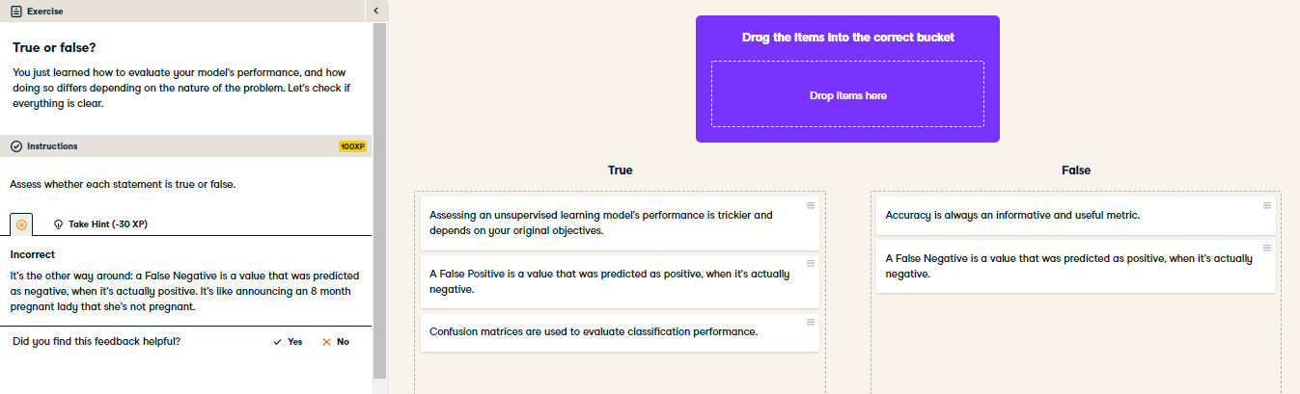

Excellent! Seems you know how to check your model's performance!

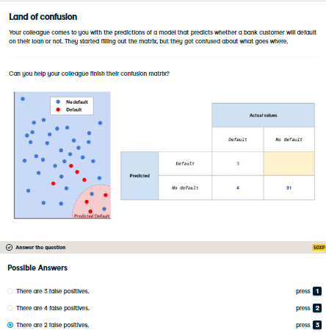

Correct, good job! Seems you're not confused at all.